**Description of NEO-6M Module:**

The NEO-6M GPS module is a compact and cost-effective solution for adding GPS capabilities to various projects and devices. It receives signals from GPS satellites to determine its precise location, velocity, and time information.

**Key Features:**

1. High Accuracy: Provides accurate positioning information with a high level of precision.

2. Fast Time to First Fix (TTFF): Quickly acquires satellite signals and calculates a position fix.

3. Low Power Consumption: Suitable for battery-powered applications due to its efficient power usage.

4. Compact Size: Small form factor enables easy integration into different projects and devices.

5. UART Interface: Communicates with microcontrollers or computers using a simple UART serial interface.

6. Multi-GNSS Support: Receives signals from multiple satellite constellations, including GPS, GLONASS, Galileo, and BeiDou, for improved accuracy and reliability.

7. Configurability: Allows configuration of various parameters such as update rate, baud rate, and output message format.

**Technical Specifications:**

Chipset: u-blox NEO-6M

Satellite Systems: GPS, GLONASS, Galileo, BeiDou

Channels:50

Accuracy:

Position: <2.5 meters CEP (Circular Error Probable , Velocity: 0.1 m/s

Update Rate: Up to 5 Hz

Operating Voltage: 3.3V to 5.0V

Operating Temperature: -40°C to +85°C

**Pinout:**

Pins Description

VCC Power supply (5 or 3.3V)

TX Serial output

RX Serial input

GND Ground

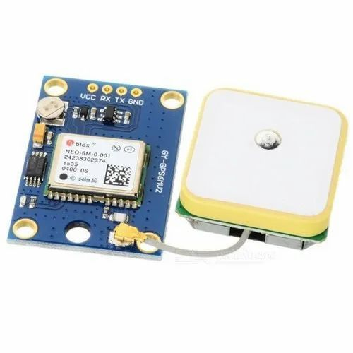**Working Principle:**

The working principle of the NEO-6M GPS module revolves around receiving signals from satellites and processing these signals to determine its precise location, velocity, and time information.

The NEO-6M GPS module's working principle involves receiving signals from satellites, processing these signals to determine position and timing information, and providing this information to the host system for various applications such as navigation, tracking, and timing synchronization.